IQA:

1.**What is difference b/w Rebase and Merge?**

Merging is a safe option that preserves the entire history of your repository,

while rebasing creates a linear history by moving your feature branch onto the tip of main

2.**What is difference b/w merge and squash?**

squash merge gives you just the file changes, and a regular merge gives you the file changes and the commit history

As a refresher, the difference between a “squash commit” and a “merge commit” is that a regular “merge” includes all the Git commits in the history of the target branch, while “squash” flattens them to one commit.

AKS:

**1) Why is load balancer needed?**

A load balancer is needed because it gives a **standard way to distribute network traffic among different services,** which runs in the backend.

**2) Define Ingress Network**

Ingress network is defined as a collection of rules which allow permission for connections into the Kubernetes cluster.

**3) Explain Replica set**

A Replica set is used to keep replica pods stable.

It enables us to specify the available number of identical pods.

This can be considered a replacement for the replication. Controller

**4) What do you mean by persistent volume?**

A persistent volume is a storage unit that is controlled by the administrator. It is used to manage an individual pod in a cluster.

**5) Explain PVC**

The full form of PVC stands for Persistent Volume Claim. It is storage requested by Kubernetes for pods. The user does not require to know the underlying provisioning. This claim should be created in the same namespace where the pod is created.

**Q7. What are the different types of services in Kubernetes?**

The following are the different types of services used:

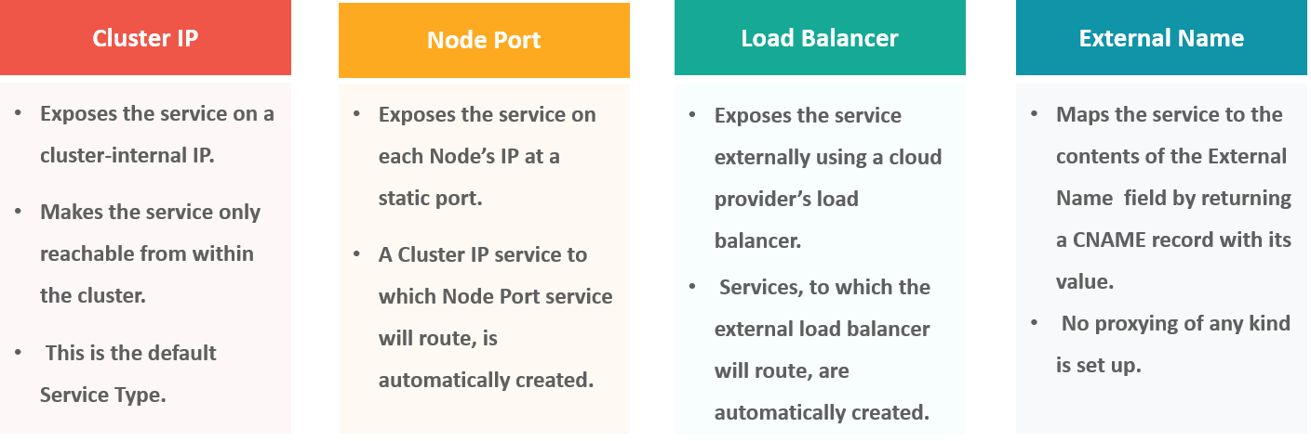

Azure:

Azure Virtual Network is the fundamental building block for your private network in Azure. A virtual network enables many types of Azure resources, such as Azure Virtual Machines (VM), to securely communicate with each other, the internet, and on-premises networks

Key scenarios that you can accomplish with a virtual network include:

* Communication of Azure resources with the internet
* Communication between Azure resources
* Communication with on-premises resources
* Filtering network traffic
* Routing network traffic
* Integration with Azure services.

**Subnets**: Subnets enable you to segment the virtual network into one or more subnetworks and allocate a portion of the virtual network's address space to each subnet.

You can then deploy Azure resources in a specific subnet

VNP:

Virtual network peering enables you to seamlessly connect two or more [Virtual Networks](https://learn.microsoft.com/en-us/azure/virtual-network/virtual-networks-overview) in Azure. The virtual networks appear as one for connectivity purposes. The traffic between virtual machines in peered virtual networks uses the Microsoft backbone infrastructure. Like traffic between virtual machines in the same network, traffic is routed through Microsoft's *private* network only.

Azure supports the following types of peering:

* **Virtual network peering**: Connecting virtual networks within the same Azure region.
* **Global virtual network peering**: Connecting virtual networks across Azure

Azure Infra through terraform using Azure DevOps

Azure provider

Azure Resource

Azure Networking

Azure Database

Azure key-vault

One resource -multiple

Multiple resource –multiple networking